|  |
| --- |
| Stress Lab Games |
| ChromeDome |
| Game Design Document |
| Version 3.00  All work Copyright © 2019 by Stress Lab Games.  All rights reserved. |
| George Zhou - 300613283  Arielle Mueller- 301037045 |
|  |

|  |
| --- |
| November 22th , 2019 |

**Table of Contents**

**Version History**

Ver 1.00 Initial Commit

Ver 2.00 Level Creation

Ver 3.00 Multiple Laser, Scene Transitions, Scoring Manager

1. **Game Overview**

Player will be fighting their way through enemies, within the predetermined levels. They will encounter different types of bullets and a final boss in the 3rd level.

1. **Game Play Mechanics**The game is a 3rd person 2D top down.

The player will control their with keyboard controls to dodge and shoot bullets.

1. **Camera** The camera setting has been determined to be a top down view. Players will be able to view the game setting just like they are viewing a map.
2. **Controls**

**Keyboard*:***

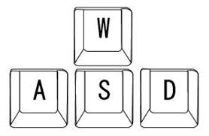

Movement is controlled by WASD keys.

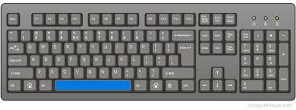

Use the spacebar to use regular bullets to shoot at enemies.

Use E key to use blue bullets to slow enemies. (E key is implemented but slow is not)

Use Q key to place green mines to blow up enemies. (Mine explosion isn’t implemented yet)

1. **Menu and Screen Descriptions**

*The menu screen will preview one of the playable characters, while also including the title of our development team “Stress Lab Games”. The player will be able to select from the menu the following functions: start, instructions and exit game. (To be added)*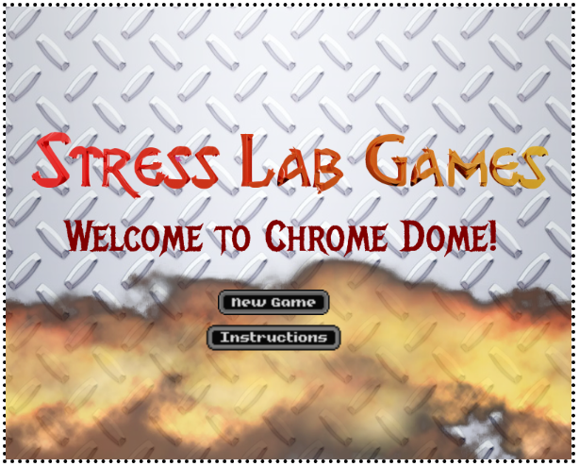

*INSTRUCTIONS/TUTORIAL:*

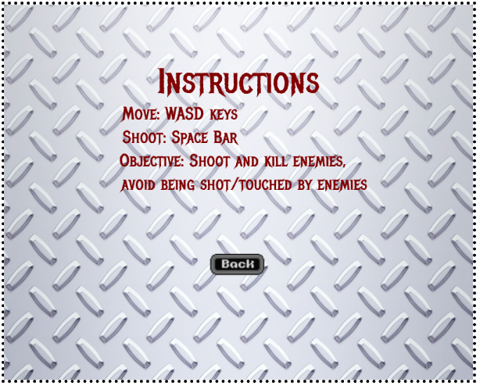

*TRANSITION 1*

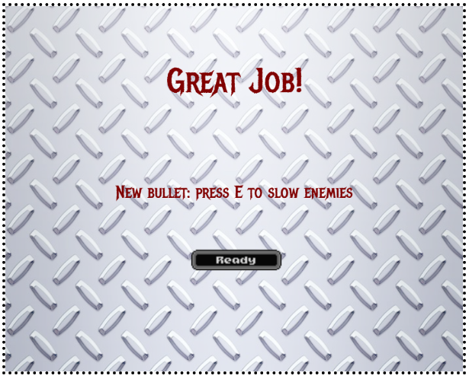

*TRANSITION 2:*

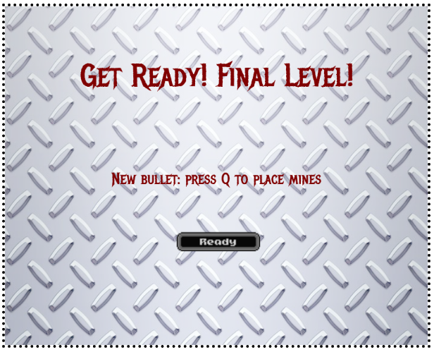

1. **Game World**

The game world will be set in the grounds of the battle arena.

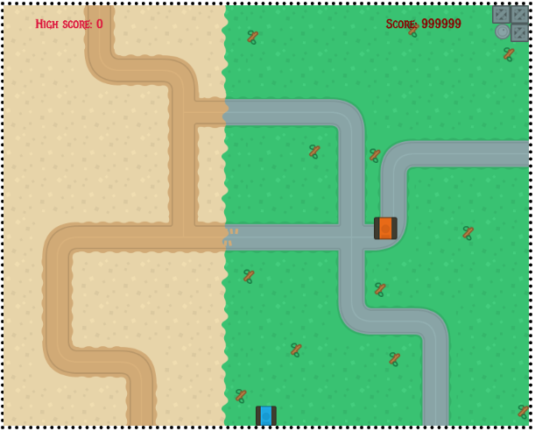

*LEVEL 1 [DESERT]:*

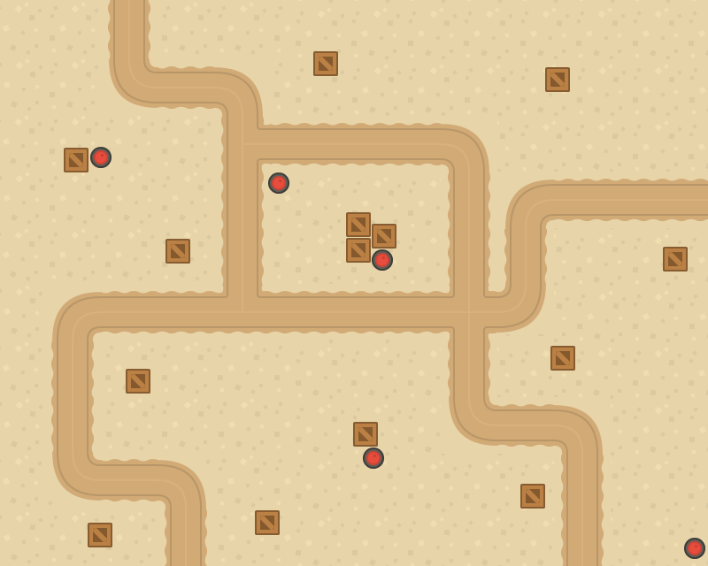

*LEVEL 2 [SPLIT]:*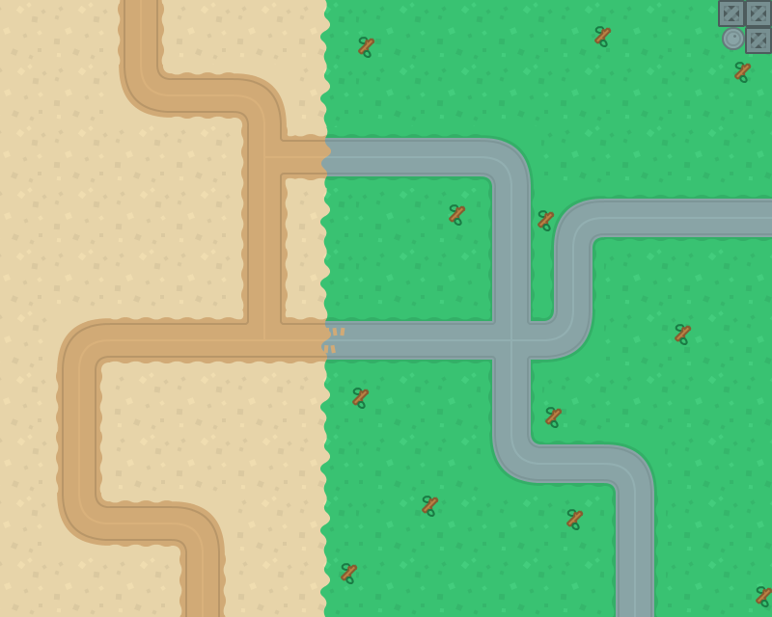

*LEVEL 3 [BOSS] [GRASS]:*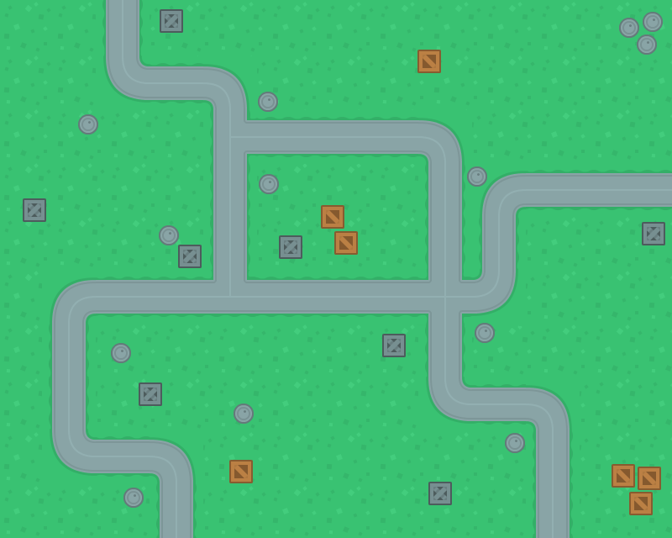

*GAME OVER SCENE:*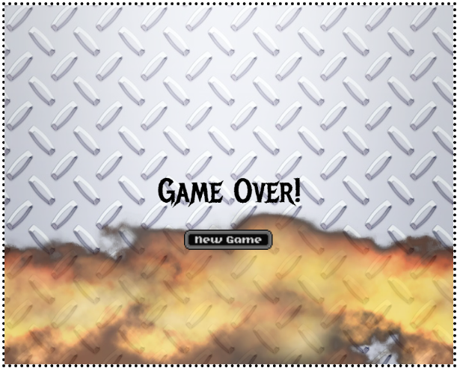

*WIN SCENE:*

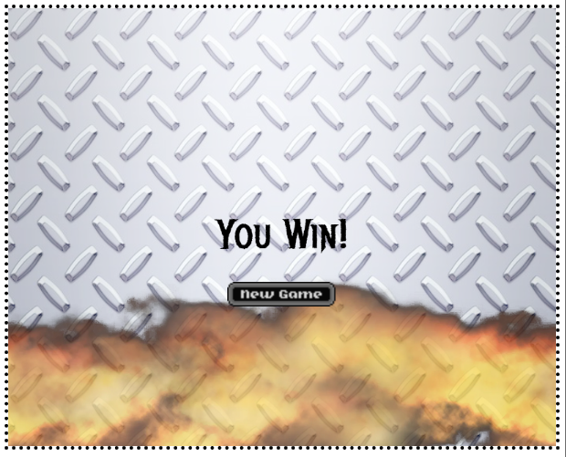

1. **Levels**

**[LEVEL 1]**

GRASS LEVEL: Introduces Venom and basic controls to the player. Has to destroy enough Venom, reach a specific score to progress to the next level.

**[LEVEL 2]**

SPLIT LEVEL: Introduces the freeze ray to the player. Similar structure to level 1 in reaching a specific score to progress to the final level.

**[LEVEL 3 .. BOSS LEVEL]**

The final level (DESERT LEVEL): Introduces placeable mines, players encounter a higher health/difficulty boss which they have to destroy in order to win the game. You also have to avoid it’s minions (Venom) while the player attempts to destroy the Ultra Tank

1. **Game Progression:**

**Characters:**

**Playable Character:**

**[Splodge] Player Character:**

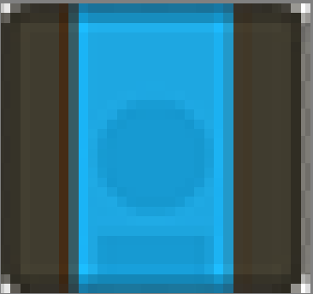

**[Venom]Enemies: Destoryable Characters**

The player has to avoid, and shoot to destroy each destroyable spawned while avoiding their lasers.

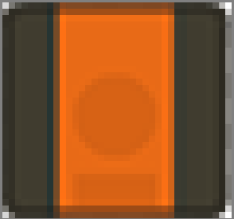

**[Ultra Tank] End Level Boss - Destroyable Character:**

Higher health than the other enemies you’ve encountered.

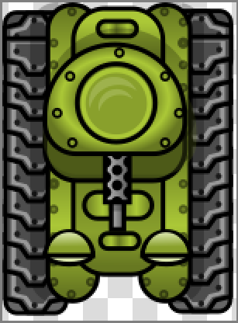

1. **Loadouts**

**Main Weapon: Laser shooter  
[Lasers]**



Laser Name: Original

Laser Description: Average laser, nothing special here

Laser Effect: Destroys enemies

(larger than in game to show colour more accurately)



Laser Name: Freeze Ray

Laser Description: Colder than the original laser (only use-able in level 2)

Laser Effect: Slows Enemies

(larger than in game to show colour more accurately)



Laser Name: Shrink Ray

Laser Description: Shrinks your enemies to half the size(only use-able in the final level)

Laser Effect: Makes your enemies half their original size

(larger than in game to show colour more accurately)

1. **Design Notes**

*-Levels must feel like an advancement*

*-Each arena will have seperate elements to them. (freeze ray, shrink ray, etc)*